AGENT 1 – CONTENT + SEO + LINKEDIN AUTOMATION
Goal
Automate daily blog creation and LinkedIn posting.

Flow:
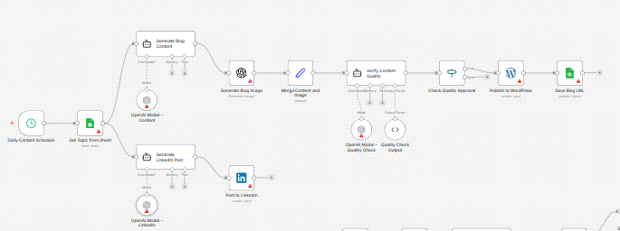USER STORIES
US1 – Topic Selection
As a Marketing Manager,
I want the system to automatically pick the next unused topic from Excel
So that content production is consistent.
US2 – Blog Generation
As SEO Head,
I want AI to generate SEO-optimized blogs
So that we rank organically.
US3 – Quality Control
As Brand Owner,
I want a second AI validation layer
So that content quality is verified before publishing.
US4 – Auto Publishing
As Marketing Team,
I want approved blogs published automatically
So that manual work is removed.

WORKFLOW LOGIC
DAILY CRON JOB – 1x per day
Step 1: Pick Topic
- Read Excel Sheet: Content_Pipeline.xlsx
- Filter where:
  - Status = “Pending”
  - URL = Empty
- Pick top row

Step 2: AI Blog Generation (OpenAI)
Prompt Structure:
Write a 1500-word SEO blog article.
Topic: {Topic}
Target audience: Online Travel Agencies, B2B travel platforms, TMCs
Include:
- SEO title
- Meta description
- H1, H2, H3 structure
- FAQ section
- Internal linking placeholders
- 3 image suggestions
- CTA section
Tone: Authoritative, enterprise B2B

Step 3: Internal Linking Logic
System pulls:
- Existing Vervotech URLs
- Match keywords semantically
- Insert contextual anchor links
Example:
If topic includes “hotel mapping” → link to mapping page

Step 4: Image Generation
Use:
- DALL·E / Midjourney API
OR
- Pull stock from predefined library
Auto compress & add alt tags

Step 5: AI Quality Verification Agent
Second prompt:
Review the blog content.
Check for:
- SEO optimization
- Grammar
- Clarity
- Keyword density
- Logical flow
- Brand alignment
Return:
APPROVED or REJECTED with reasons.
If rejected → regenerate.

Step 6: Publish to WordPress
Using:
- WordPress REST API
Actions:
- Create post
- Add featured image
- Insert metadata
- Set category + tags
- Publish

Step 7: Update Excel
- Save Blog URL
- Mark status = Published
- Save publishing date

LinkedIn Automation (Parallel)
Step 1:
Use same topic
Prompt:
Write a LinkedIn post (300 words)
Hook-driven opening
Add CTA
Add 5 hashtags
Encourage engagement
Step 2:
Post via LinkedIn API
Step 3:
Log LinkedIn post URL into Excel

AGENT 1 KPIs
- Blogs published per month
- Organic traffic growth
- Time saved
- LinkedIn engagement rate

